Exercise 1: Logging Error Messages and Warning Levels
Implementation:
logback.xml:
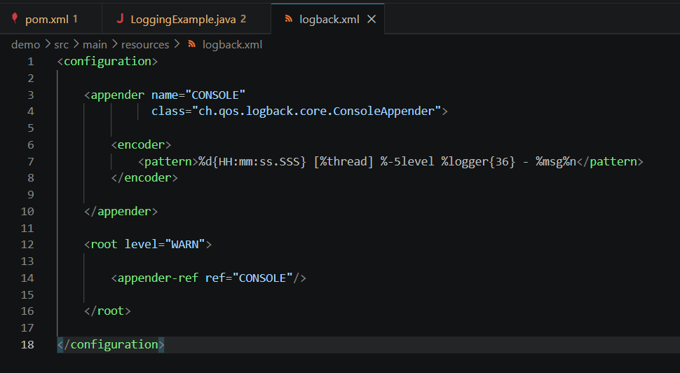

LoggingExample.java:
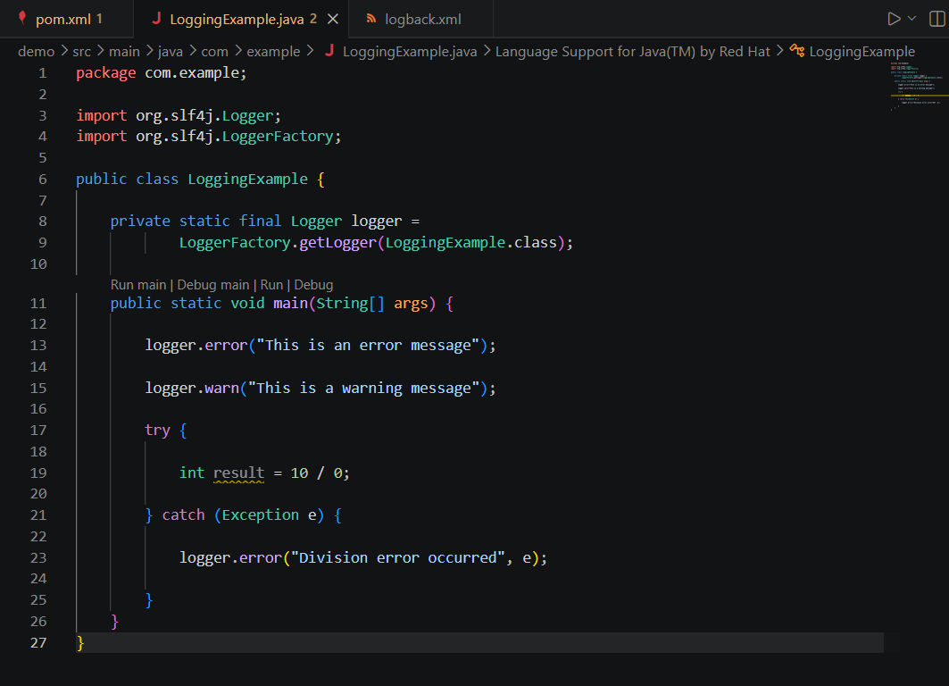
Output:
